Adam Is Me - Editor

This document describes the Level and Campaign editor for ”Adam Is Me” game.

The editor was created primarily for the team working on the game but should be easy enough to be used by external users.

# User interface

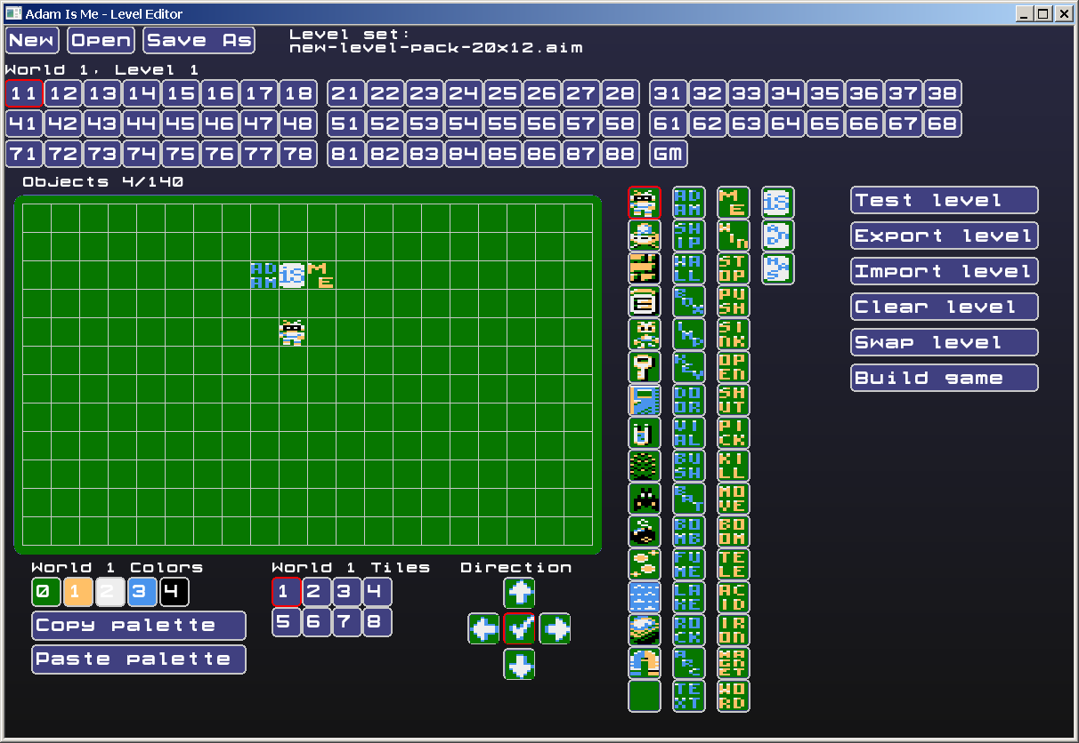

The editor has been designed to have the look & feel of “Robbo Kreator” <http://poklik.pl/robbokreator/> , because it has quite a big user-base. Users of “Robbo Kreator” should feel at home, however “Adam Is Me” is a much more complex game than “Robbo” and the editor needs additional complexity.

## Level Set options



On the top of the screen there are options to create a level set (campaign). There are 3 options, to create a New level set, to Open existing one and to Save As the currently edited under a new name. The editor automatically saves all the changes done therefore there is no Save button.

The original Level Set of the released game can be loaded from the **level_set** folder.

## List of Levels

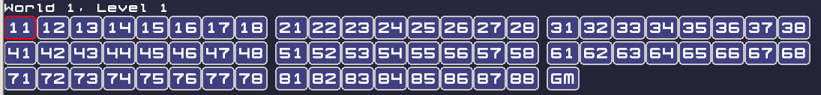

This is a list of all the campaign worlds, split by 8 levels per each world. The one edited is marked with a red border. There 8 levels * 8 worlds = 64 levels in the campaign. The last one to select (GM) is a “Global Map” where worlds can be placed.

Levels can be selected either using the left mouse button or with keyboard shortcuts **[** and **]** for the previous/next level.

## Level Map

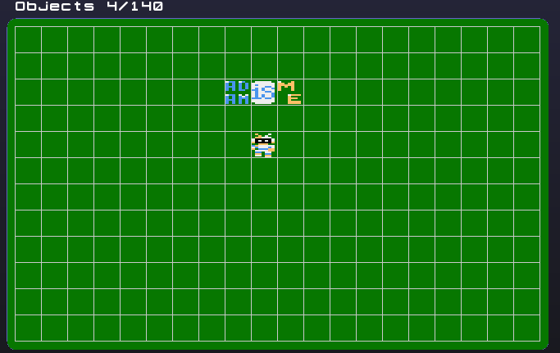

Level Map is a place where game elements can be placed. Placing is done using the left mouse button, while the right mouse button removes the element.

UNDO was never implemented (lack of time), therefore cautiousness is needed, especially that changes are auto-saved.

## Elements to place on the Level Map

Depending on the selected world (or Global Map) user will have different elements available to place on the Level Map.

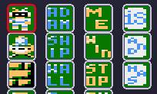

On the standard maps user has following columns available:

1. Objects
2. Nouns representing the Objects
3. Properties of objects
4. Operators

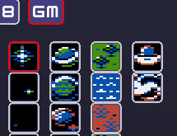

On the Global Map (or the “Galaxy Map” in case of the default tilesets) objects to put are grouped into following columns are available:

1. Background elements (non-interactive), for decoration
2. Representation of Worlds that players can enter, require some space around them (5x5) in the game to display the world levels.
3. Non-passable walls (from the world) that can be used to limit places reachable by the player on the Global Map, or for decoration
4. Vehicle (ship) of the player that moves on the map and Game Exit that is open when enough levels are complete

## Colors of the world

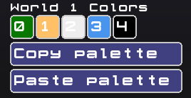

Colors are set for the whole world (set of 8 levels) instead of for each level individually. Graphics in the editor are automatically updated according to selected colors, therefore the user sees instantly the changes. Additionally the palette can be copied and pasted between Worlds.

## Tileset of the world

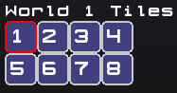

Each World (set of 8 levels) can have a different theme by assigned tileset. There are 8 different tilesets to select from.

## Direction settings

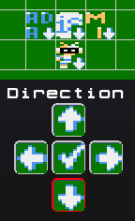

In “Adam Is Me” everything on the Level Map is facing some direction (up, down, left or right). Using these buttons you can turn on the display of the directions and set a new one (with the left mouse button) on the Level Map. Direction is important for objects with property MOVE or MAGNET.

## Level Options

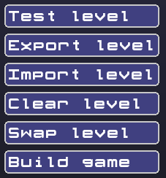

There are different helpful options available:

* Test level - test the level quickly in the editor, without building the game. The testing is quite limited currently (no “reverting time” implemented)
* Export level - export a level to external file (so can be e.g. shared with the others)
* Import level - export a level from external file
* Clear level - removes all the elements from the Level Map
* Swap level - after clicking this button the currently edited Level will be swapped with other one selected from List of Levels
* Build game - option to build a game (the whole campaign)

# Custom graphics

All the in-game graphics are replaceable and the editor is compiling them to files that can be loaded by the game on Atari. Graphics are stored in palette-indexed PNG images placed in the gfx_atari folder (0.png to 8.png). These images can be edited in Grafx2 or Graph2Font, however they need to keep order of the colors in the palette (e.g. color 0 is background).

With custom graphics the game theme could be switched from futuristic Space e.g. to Medieval times (player could travel by horse to visit castles).

# Editor TODO

* Settable number of levels in the campaign and to be finished
* Undo in the Editor - was never implemented
* Reverting time (undo move in “Test Level”) - was never implemented
* Maps of different sizes (instead of 20x14) so gfx could be displayed e.g. on ZX Spectrum

# Compilation

Editor currently is available for Windows platform only, however sources should be portable

enough to be compiled without bigger issues on other desktop platforms. The game (and Editor) is written primarily in portable C language. It has dependency on Allegro 5 library and Windows version was compiled in Visual Studio 2019 Community Edition. There is Allegro5 backend for SDL therefore compilation of the Editor to web using Emscripten should be also possible.